|  |
| --- |
| Circle Language Spec: Commands |

## Active Clauses in a Command Call in a Diagram

This article demonstrates a situation of command objects.

This article illustrates how active clauses in a command call look in a diagram.

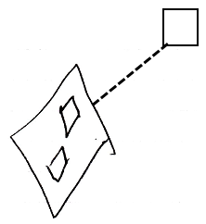

The diamond shape is a command call. The command definition of the command call is pointed out by the dashed line, pointing at the square, which is the command definition. The diamond contains two diamond shapes, that do not redirect. Those are the active clauses inside the command call. They are clauses, because they are situated inside a command symbol and they do not redirect their target.